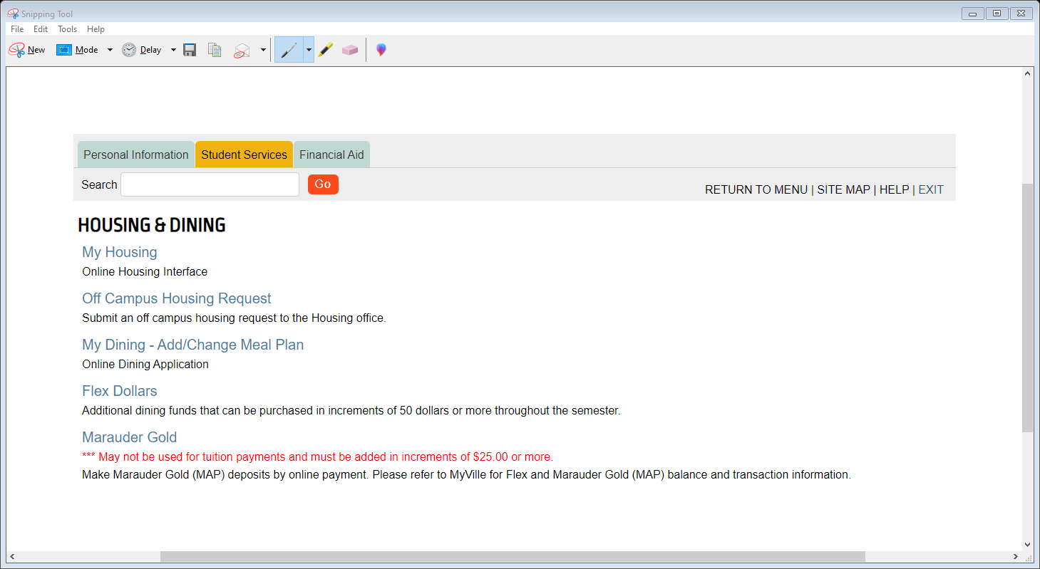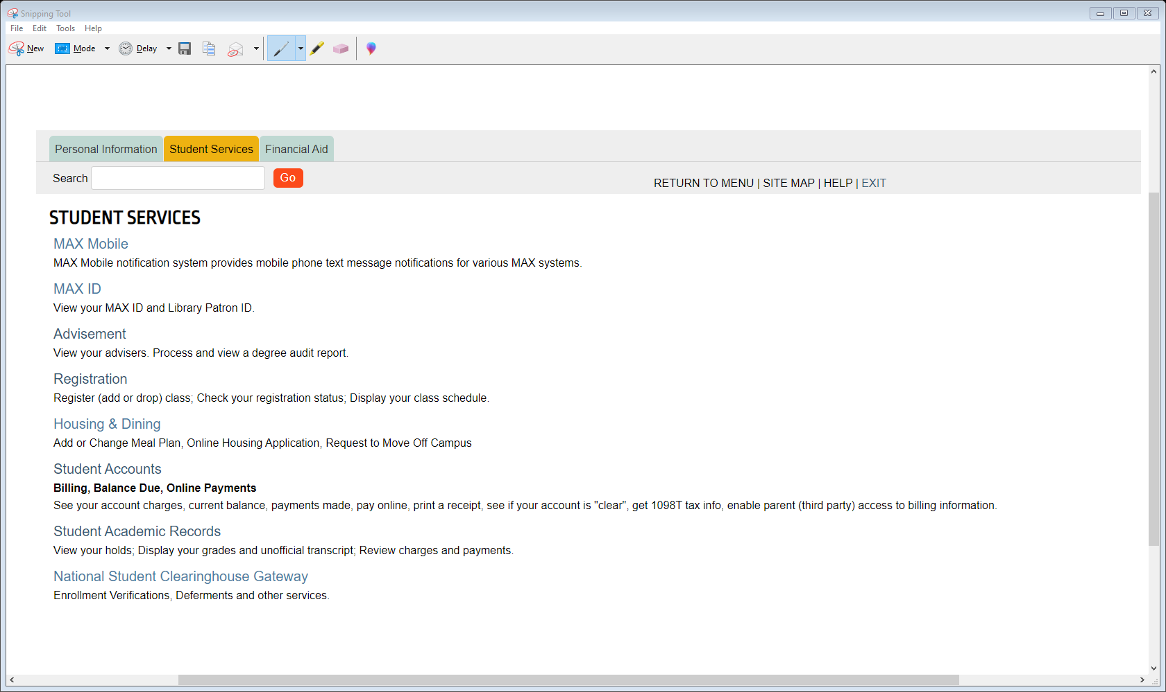

STEP 1:

Click and login to your max account. Then Click on Housing & Dinning. After you click on My Housing.

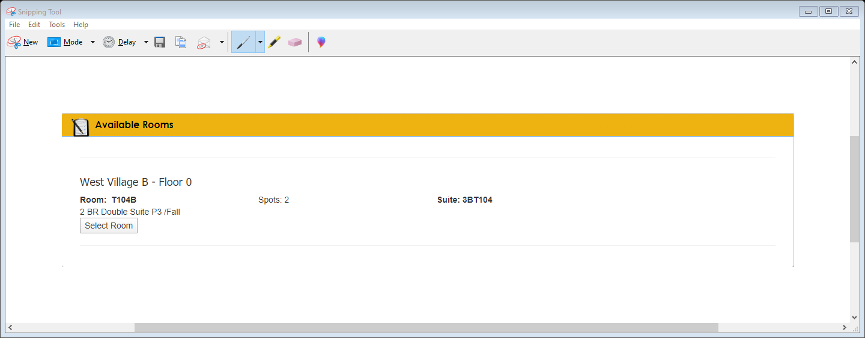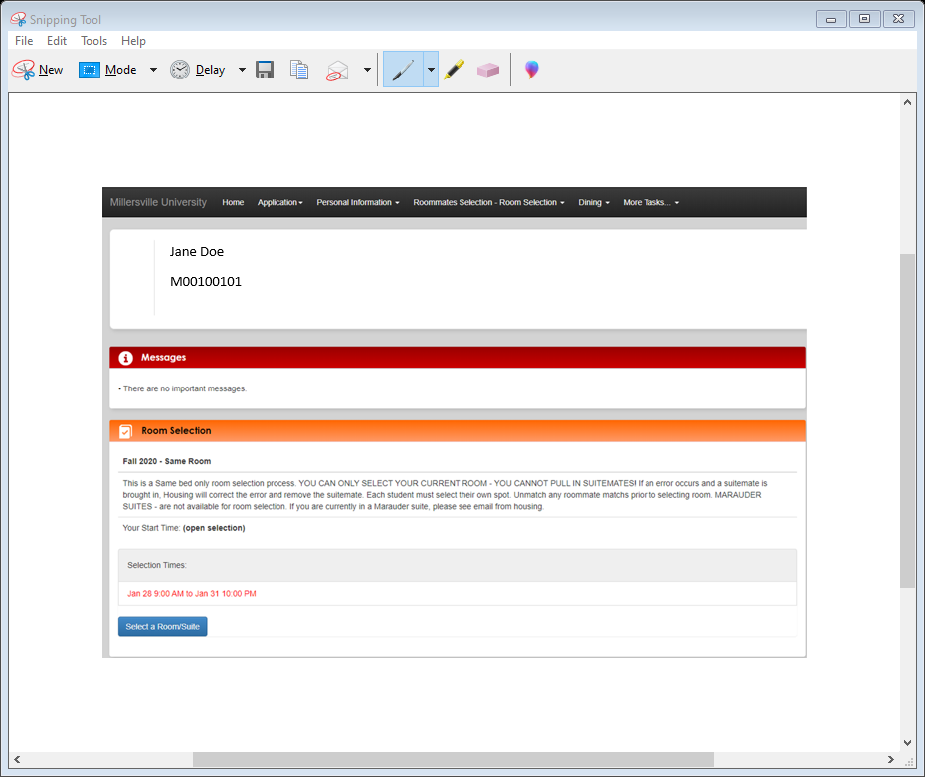

Step 3:

Available Rooms page will show. The room you are currently residing in will appear. You will need to click on the Select Room button.

Step 2:

This page will appear. You want to click on Select a Room/Suite button.

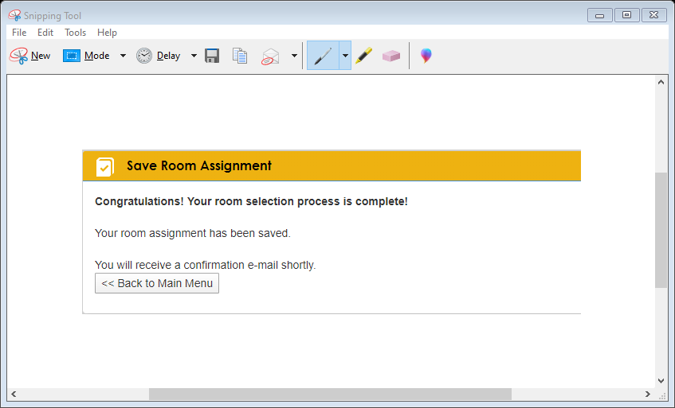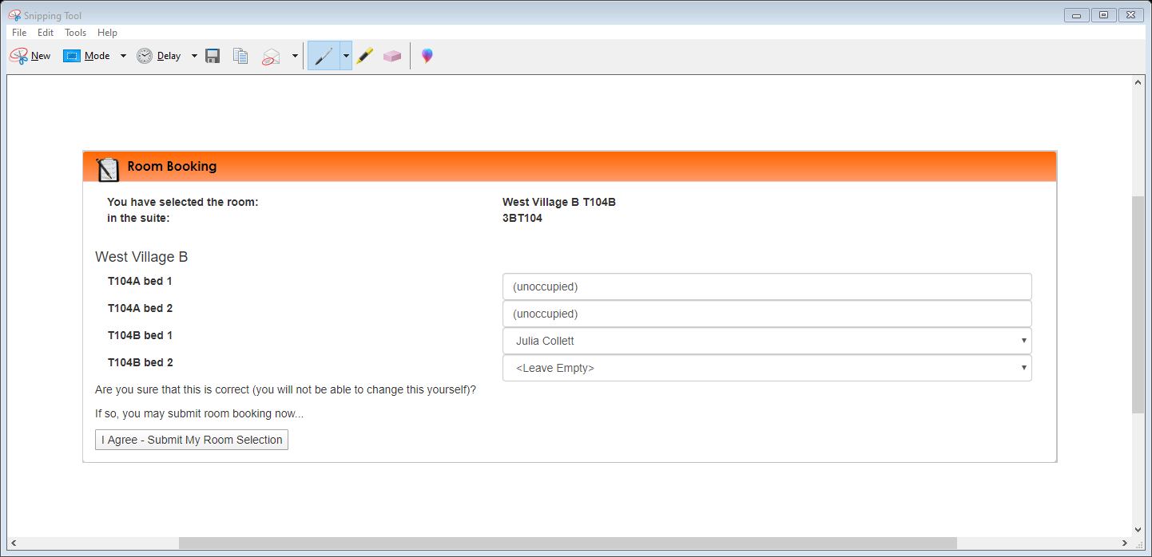

Step 5:

Save Room Assignment page will show. Just click on Back to Main Menu button.

Step 4:

The Room Booking page will appear. It will ask you if this is correct. If it is correct click on

I Agree – Submit My Room Selection button.

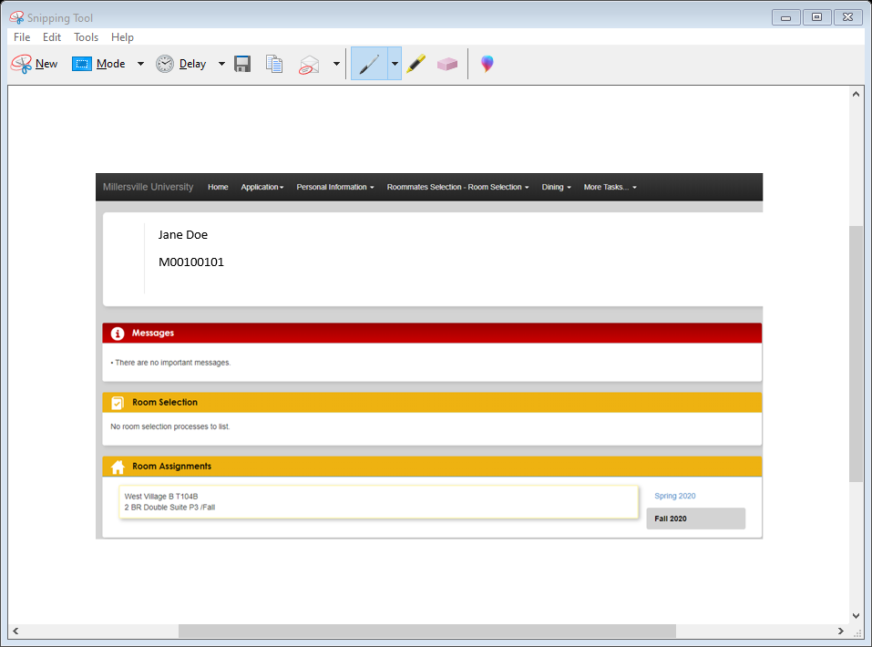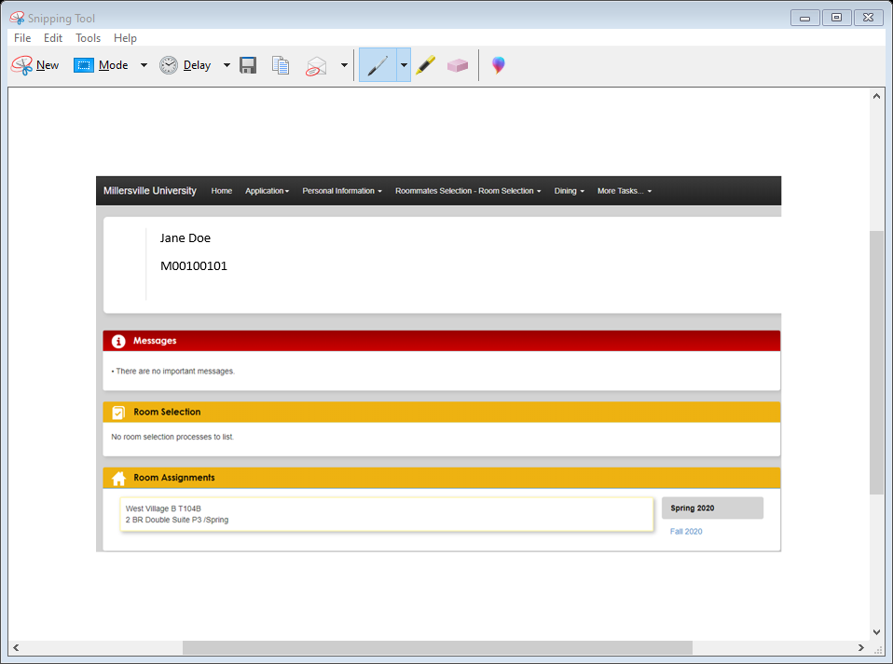

After you have finished the selection process, your main page should look like this. Bothe semesters will be available for viewing.