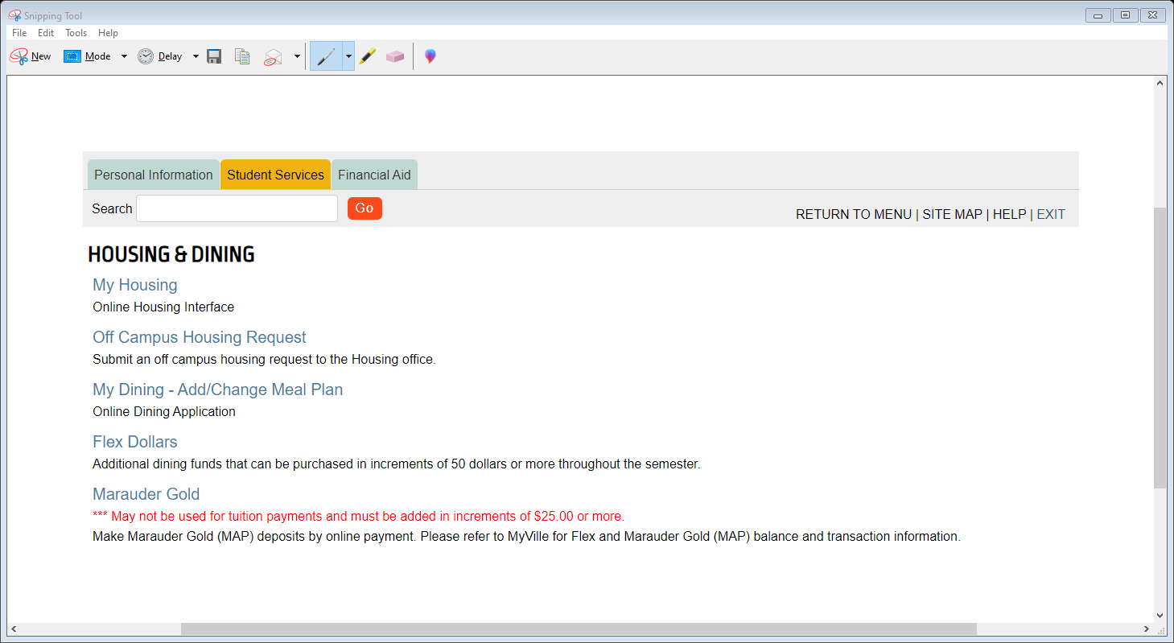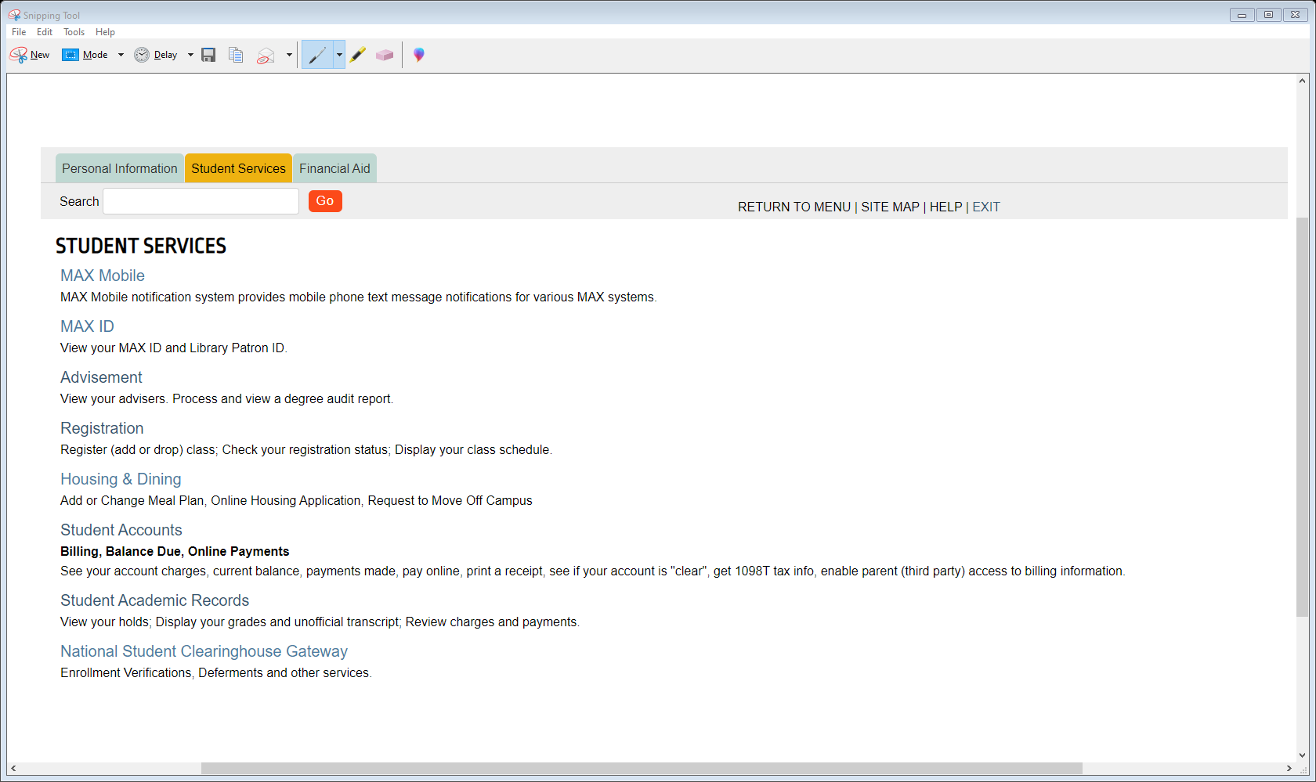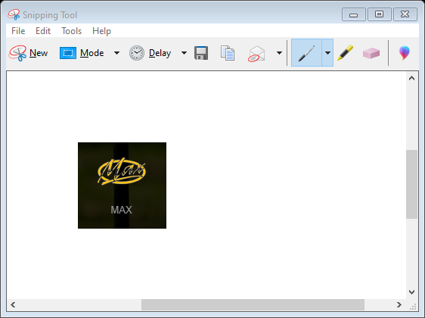

STEP 1:

Click and login to your max account. Then Click on Housing & Dinning. After you click on My Housing.

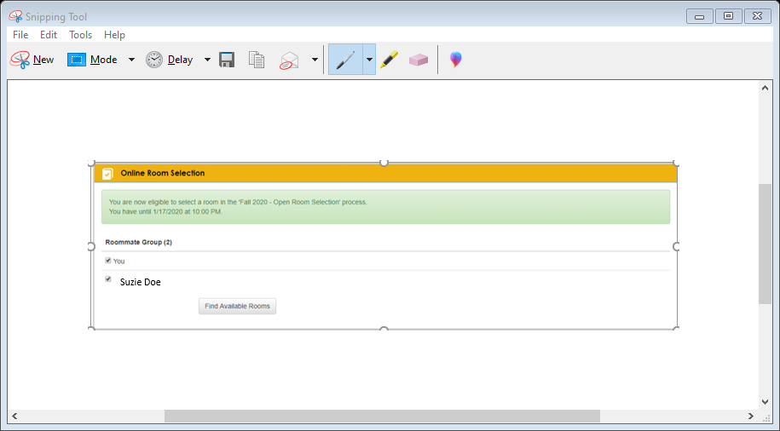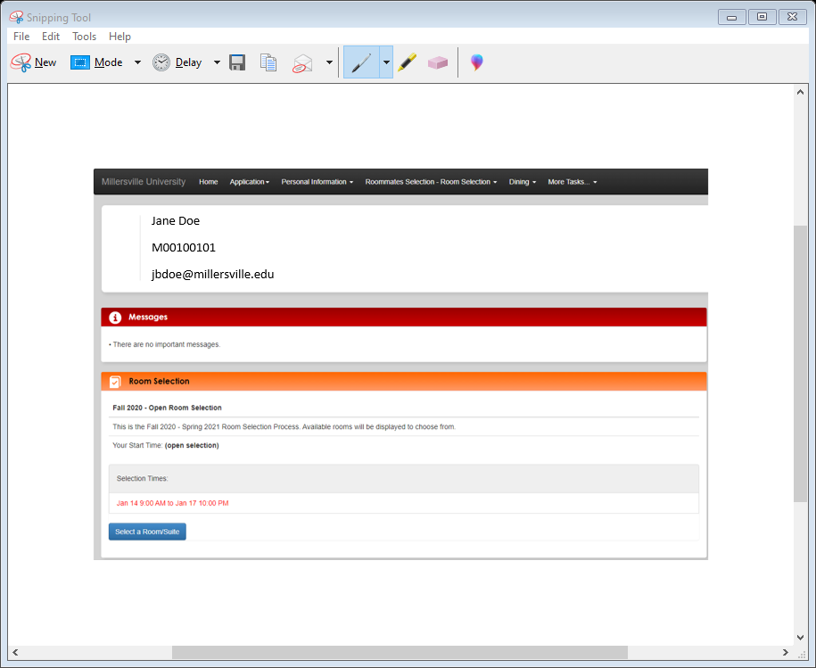

STEP 3:

Online Room Selection should pop up with the roommate(s) you selected.

Then you click on Find Available Rooms.

STEP 2:

This page will appear. You want to click on Select a Room/Suite.

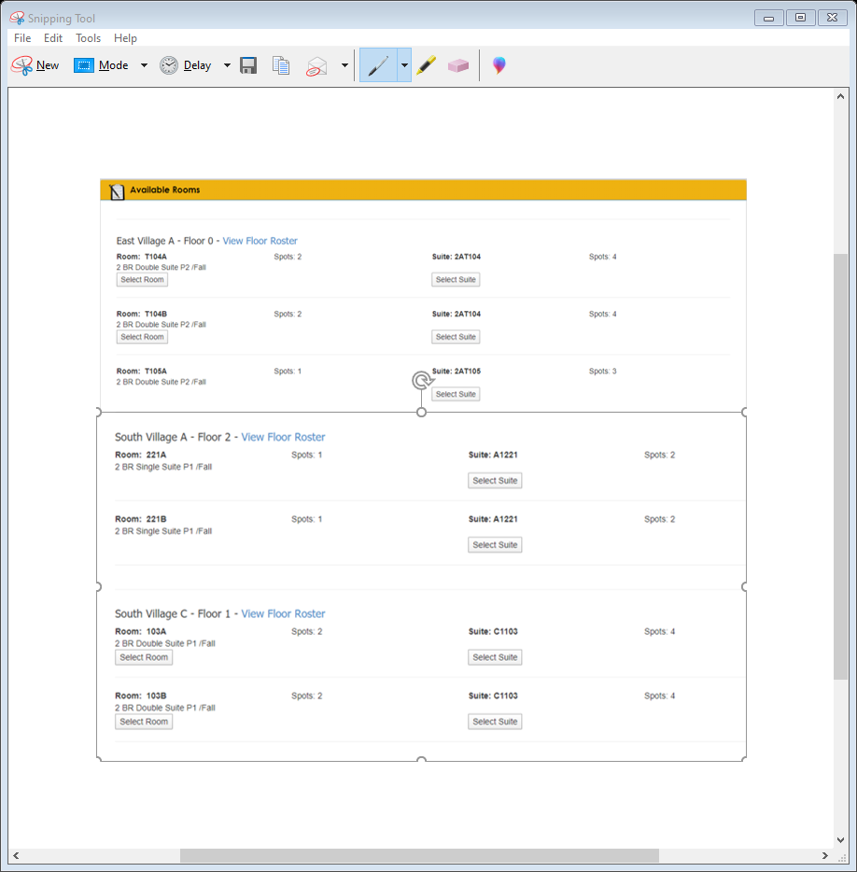

STEP 4:

A list of all the rooms in each of the buildings will come up. Scroll until you find the building you want then look for the room you want.

After you find it click on the Select Room Button

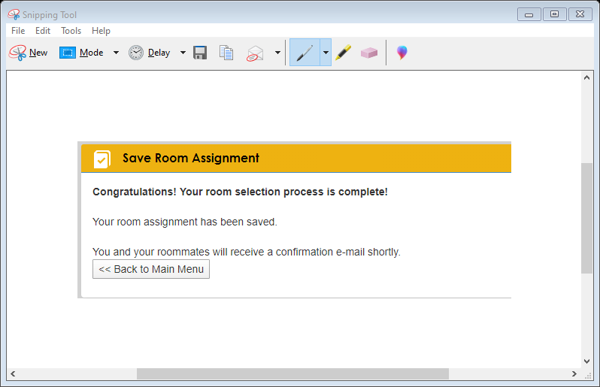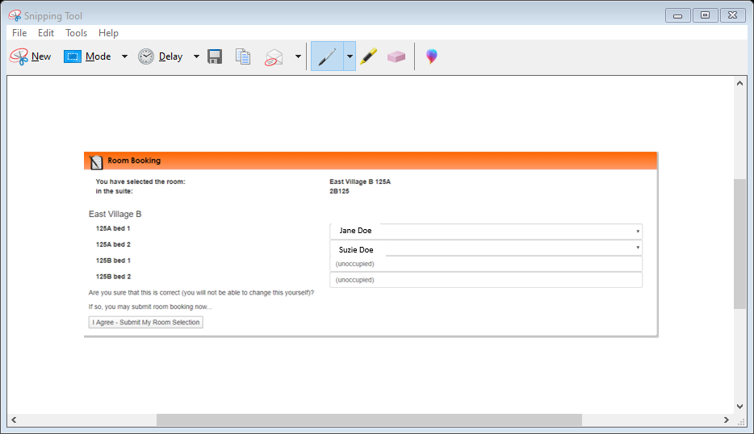

STEP 5:

Make sure everything looks okay and then click I Agree – Submit My Room Selection.

Then Save Room Assignment page will pop up and you will have to click on Back to Main Menu

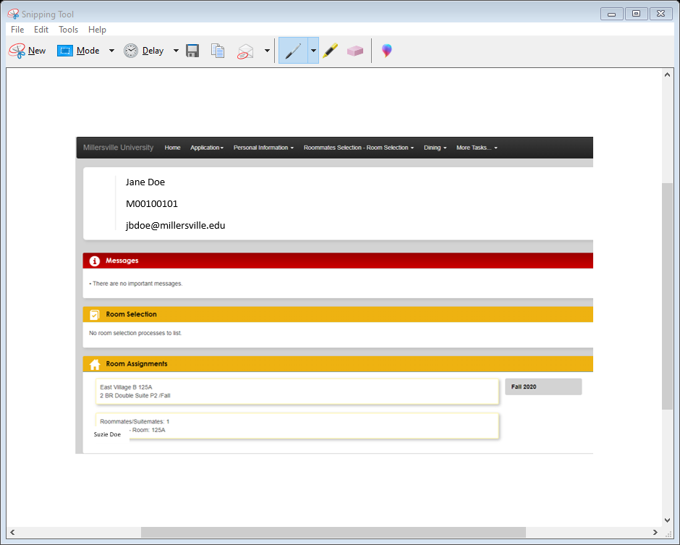

STEP 6:

Finally, you check to make sure that both you and your roommate are in the correct room on the main page.