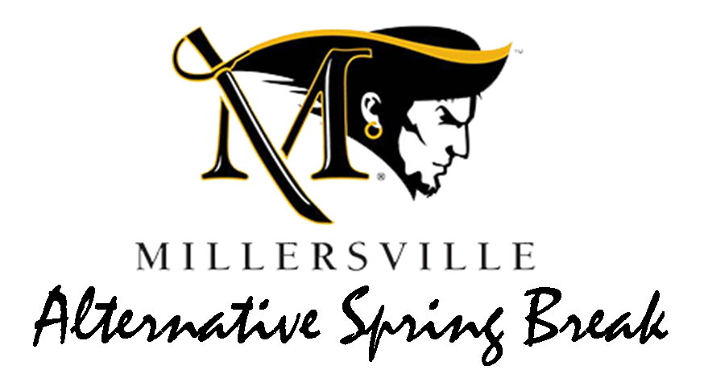

March 10 - 17, 2018

Applications are due October 6th!
DEADLINE EXTENDED! APPLY ASAP!

Please bring with you a copy of your insurance card!

Questions? Contact Emily at
717-871-7224 or
emily.reed@millersville.edu
Early Applications are encouraged!

About Alternative Spring Break 2018
Civic and Community Engagement and Experiential Learning and Career Management at Millersville University is proud to present its third Alternative Spring Break program! We hope you will consider applying for this opportunity to learn new things, gain new skills, meet new people, and have a great time while serving a new community. Because there are limited spots for this opportunity, the application process will be competitive, and we ask that if you apply, you are serious about making a commitment to Alternative Spring Break 2018.

Where are we going? We are excited to announce that we will be sending out two breaks!
National: Black Mountain, North Carolina
Local: Lancaster Area
When? Leaving Saturday, March 10th to return Saturday, March 17th. Note: These dates may change slightly but the trip will be within this time frame. If you apply, please check your calendars to make sure you are available from Saturday to Saturday.
Who will be going? 13- 20 Millersville students and 1-2 Millersville staff per trip.
What projects will we be doing? Each location has a slightly different focus. Each trip is unique and exciting in its own. The trips could have projects including: food pantry assistance, education focus, environmental efforts, and work with marginalized populations, etc.
What is the cost?
Students are to put a $25 deposit with their application. Then we will break the remaining balance due into sections.
Lancaster- $100 |  | North Carolina- $250
Due 10/31 (Tuesday) | $25 DEPOSIT | Due 10/31 (Friday) | $25 DEPOSIT
Due 12/1(Friday) | $25 | Due 12/1(Friday) | $75
Due 12/29 (Friday) | $50 | Due 12/29 (Friday) | $100
 |  | Due1/26 | $50

*No refunds will be given after December 29!
**If December 29th payment is not made, you forfeit your spot and your spot will go to another student.
Students are expected to participate in fundraisers!
If cost is a concern please contact Emily Reed (Emily.reed@millersville.edu or 717-871-7224)

Pre-Trip Meeting Requirements:
All trip participants will be required to attend 4 pre- trip meetings to participate in team building, fundraising efforts, and to receive updates about the trip. Dates are to be determined.
Alternative Spring Break 2016
Instructions: Please, print and carefully fill out pages 3-5. Once your application packet is complete, bring it to the ELCM Office in Huntingdon House, across the street from the University Store. Office hours are Monday- Friday 9:00am-4:30pm. At this time you will be asked to sign up for a short interview. Applications will be collected and interviews will be scheduled by Emily Reed. Contact Info: Emily.reed@millersville.edu Phone: 717 871-7224.

Participant Application
Part A. General Information
Name:
(As it appears on your driver’s license or official state I.D.)

M#:

Date of Birth:

MU Email:
Phone:
Address:

Gender:
Age:
Year in School:
Graduation Year:
Major:
T-shirt size:
Please check the following topics that interest you:

- Urban Poverty
- Rural Poverty
- Homelessness/Hunger
- Education
- Migration/Immigration
- Environmental sustainability
- Youth
- Elderly
- Veteran’s services

Please number your preference as to what trip you attend 1-3 (1 being the highest):

- Black Mountain, NC

- Lancaster Area
- No Preference

Part B. (Please attach extra sheets if necessary)

Why do you want to participate in Alternative Spring Break 2018?

Have you participated in community service activities in the past? If so, briefly explain.

Alternative Spring Break trips are a great time to learn new things and apply classroom content in a real world setting. What do you think you could learn on this trip related to the learning outcomes specific to your major?

Part C. Skills and Abilities
List and briefly explain three skills or strengths you would bring to the Alternative Spring Break group.
Do you have any specialized skills such as plumbing, construction, language, etc.?

Do you have any limitations on strenuous travel that would be relevant to an alternative spring break trip? If so, are there any accommodations that would be useful to you?

Do you have any dietary restrictions?

What else do you want us to know about you?

