Saxbys and Millersville University Police Invites you to join them for:
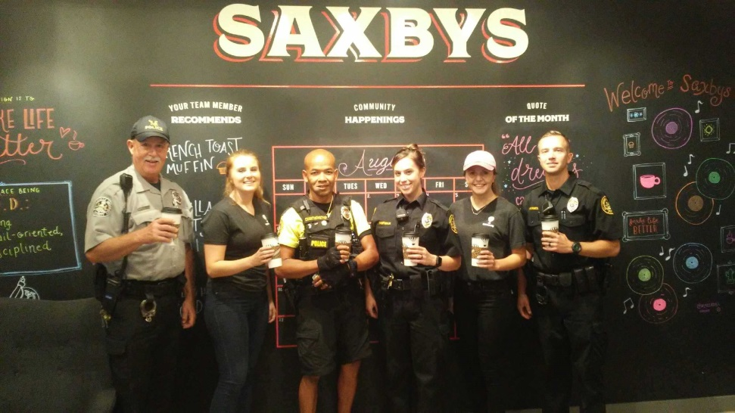
Coffee with a Cop
First 200 students will receive a FREE 12oz coffee
LOCATION:
Gordinier Hall, 30 S George St, Millersville, PA 17551
Date:
FRIDAY - 05/04/2018
Time:
4pm-6pm
See you there!

